

Evertz Microsystems Technical Operations Centre

Method of Procedure: Fix unable to route to IPG (device unsync’d)

Prepared by: | Hassan Shabbir
Revision Number: | 1.0
Revision Date: | Oct 26, 2023
Reviewed by: | Lalit Bisht, Vishal Kohli

Evertz Microsystems Ltd. 2021. Do Not Duplicate
No part of this document may be reproduced or reused in any form or by any means, electronic or mechanical, including photocopying, recording, or by any information storage and retrieval system, without permission in writing from Evertz Microsystems Ltd.

Table of Contents
Introduction: 3
Symptoms: 3
IPG is connected to Magnum but the route fails 3
Magrtrsrv.log will show begin synchronize for the IPG, without the end synchronize 4
Checking the device status will show it is not ready 5
Delete the device 5
Readd the IPG 7
Add the Links 9
Setup Static Routes: 10
Device should now be connected to Magnum and in a Ready state 12
Device will still not take routes in Magnum CH > Advanced Routes > Virtual 12
Readding the IPG caused the CH > Virtual Ports > Destination names to be reverted to the default names 14
Under CH > Names > Destination, add the names and commit the changes 14
*WARNING*: Add the device destinations under SDVN > Interfaces > Destinations, under the right table 16
In CH > Names > Destinations add the names of the device and commit changes 19
*NOTE*: In SDVN > Ports > Destinations, add the names to the Global and ENG columns 21
In CH > Source Availability, allow all sources to route to the new destinations and commit 24
Device should now show up in a synced state in Magnum 27
(Optional) Monitoring the IPG Sync Status During a Broadcast: 27

Introduction:
This MoP is provided in the event a device that is connected to Magnum but routing to it does not work.

This MoP will cover the following:
- Verifying that the issue is with the syncing of the device to Magnum
- How to remove and readd the device to Magnum
- Other settings that will need to be entered in again before the device is able to take routes through both SDVN and CH

Note: Commands may need to be changed to refer to the device that has the issue, for example, | grep ‘IPG 608 2’ will need to have the device name in single quotes changed to another device.

Note: Connect to Magnum SSH shell by logging with username etservice and password magnumhdtv.

A script is also provided at the end of the doc if you wish to monitor to make sure no devices are in the unsynced state.

Please open the Navigation Pane (using Ctrl-F) to quickly navigate this document.

Symptoms:

IPG is connected to Magnum but the route fails

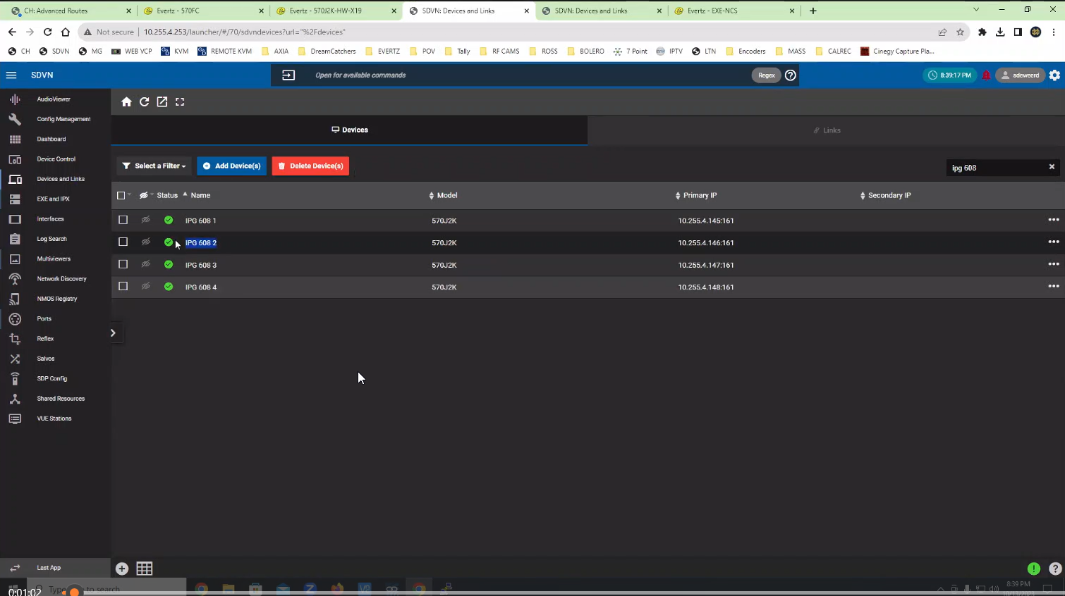

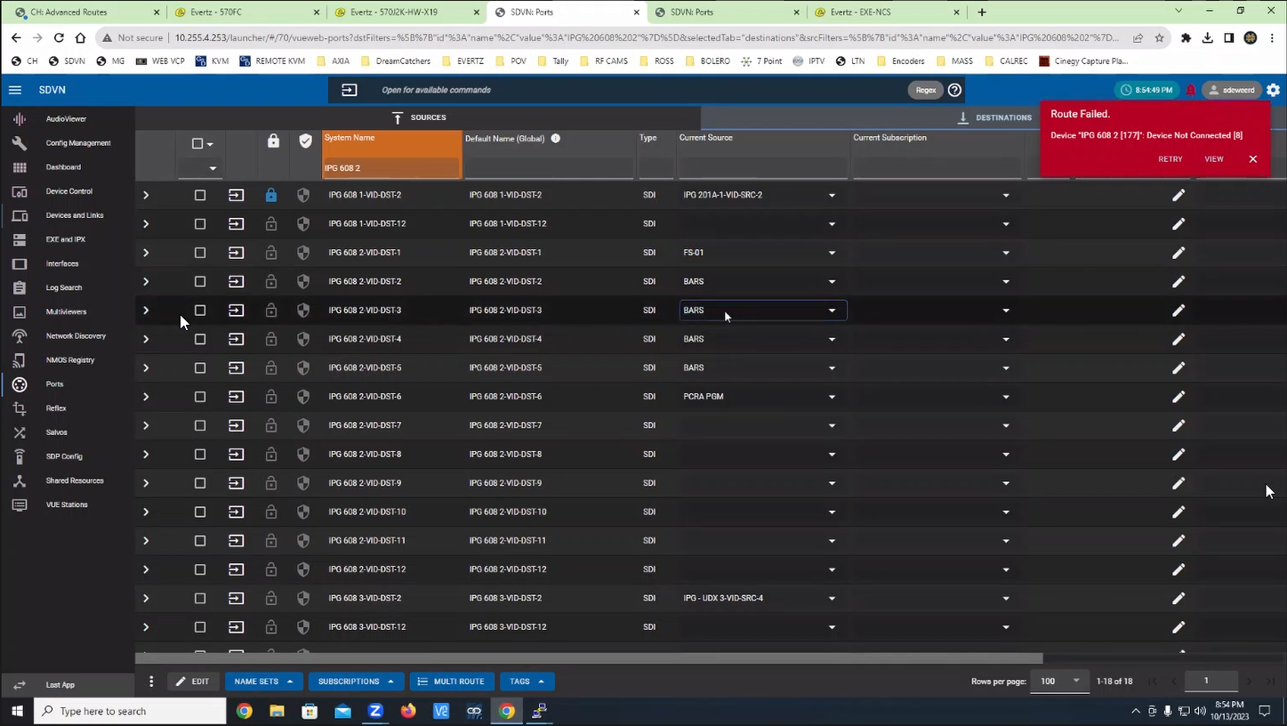

Magrtrsrv.log will show begin synchronize for the IPG, without the end synchronize when restarting the driver for the device
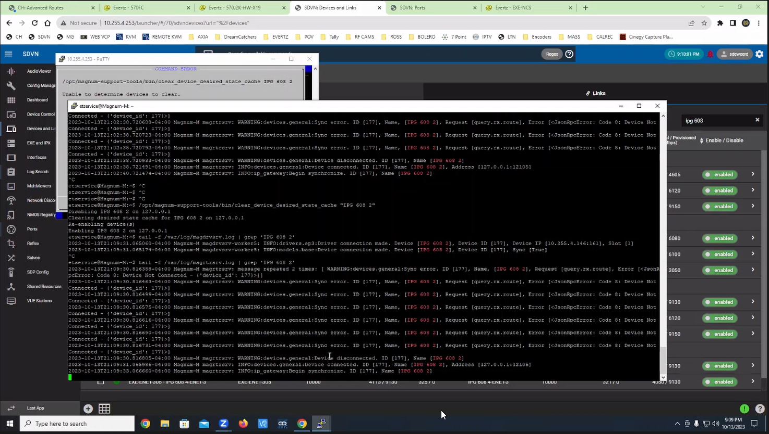

Checking the device status will show it is not ready
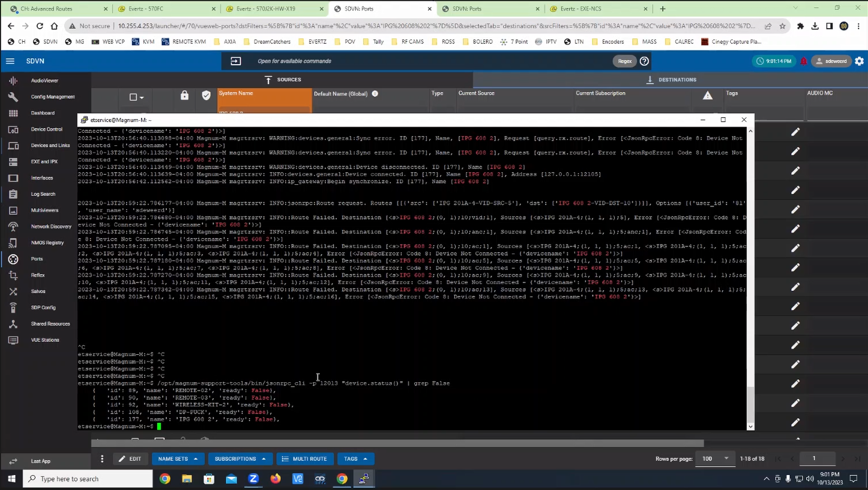

Delete the device

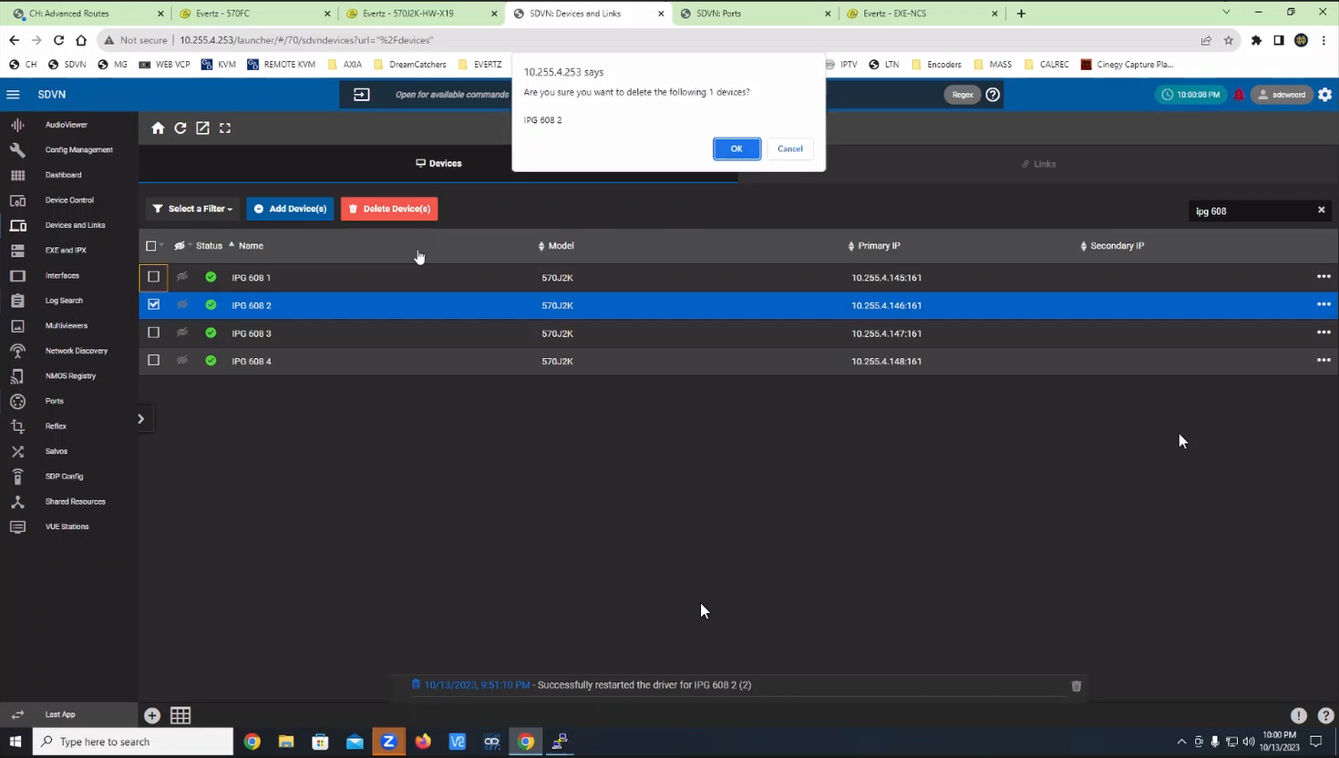

Readd the IPG
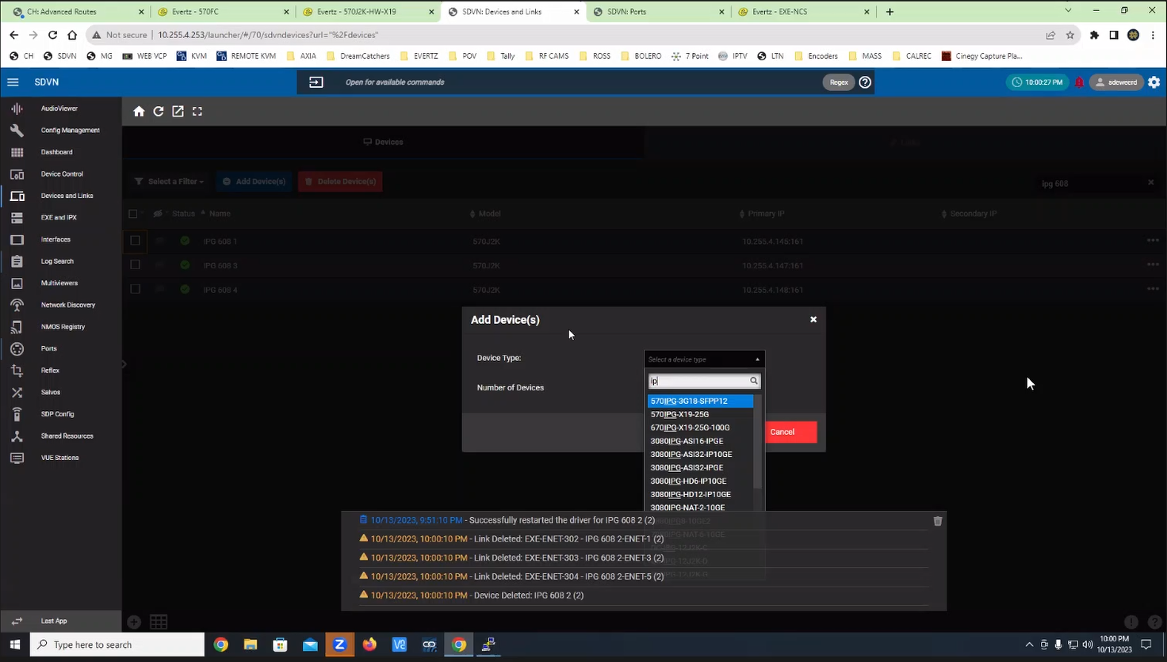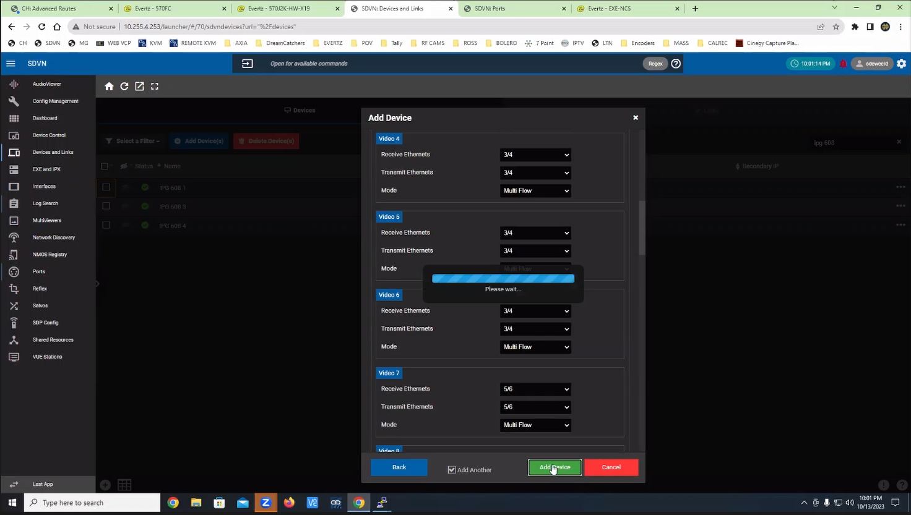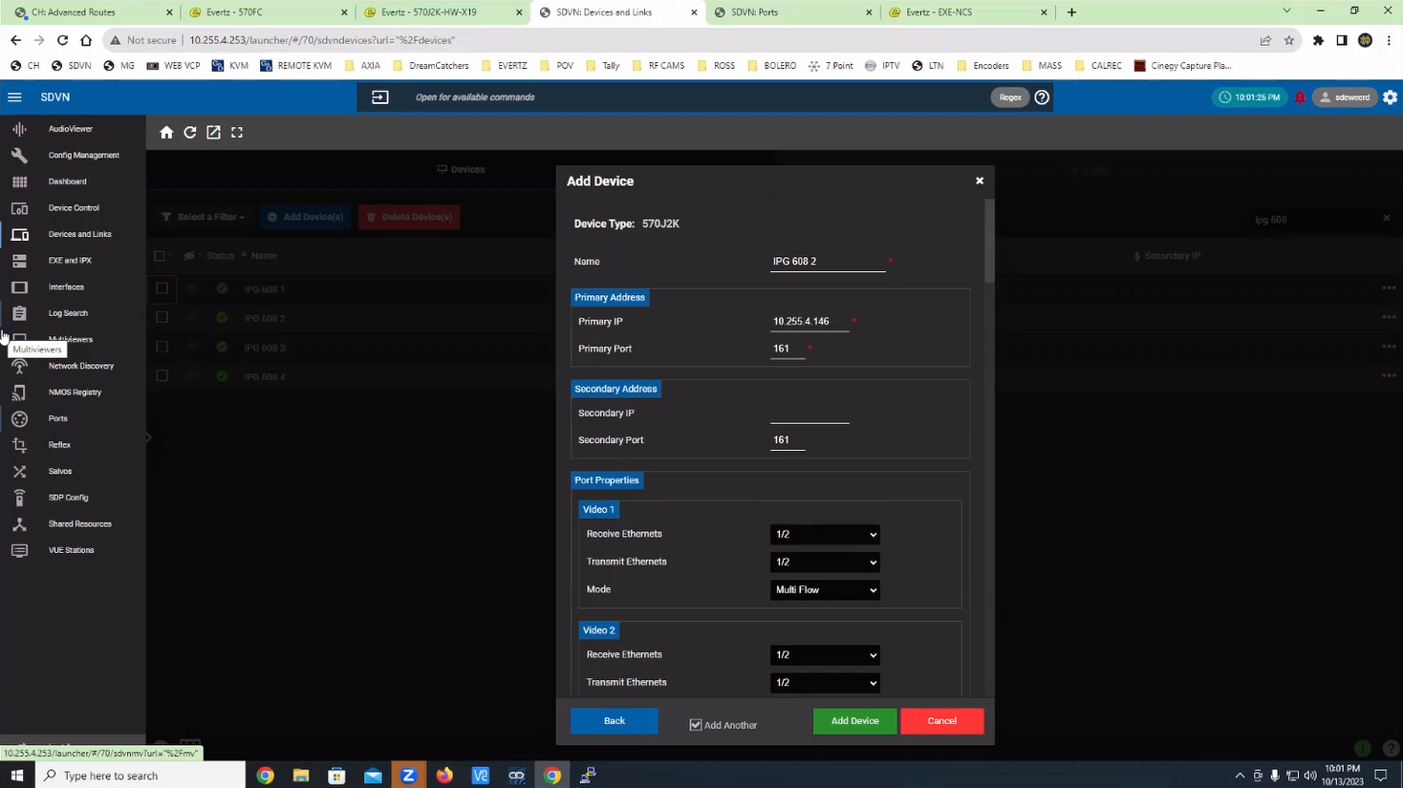

Add the Links

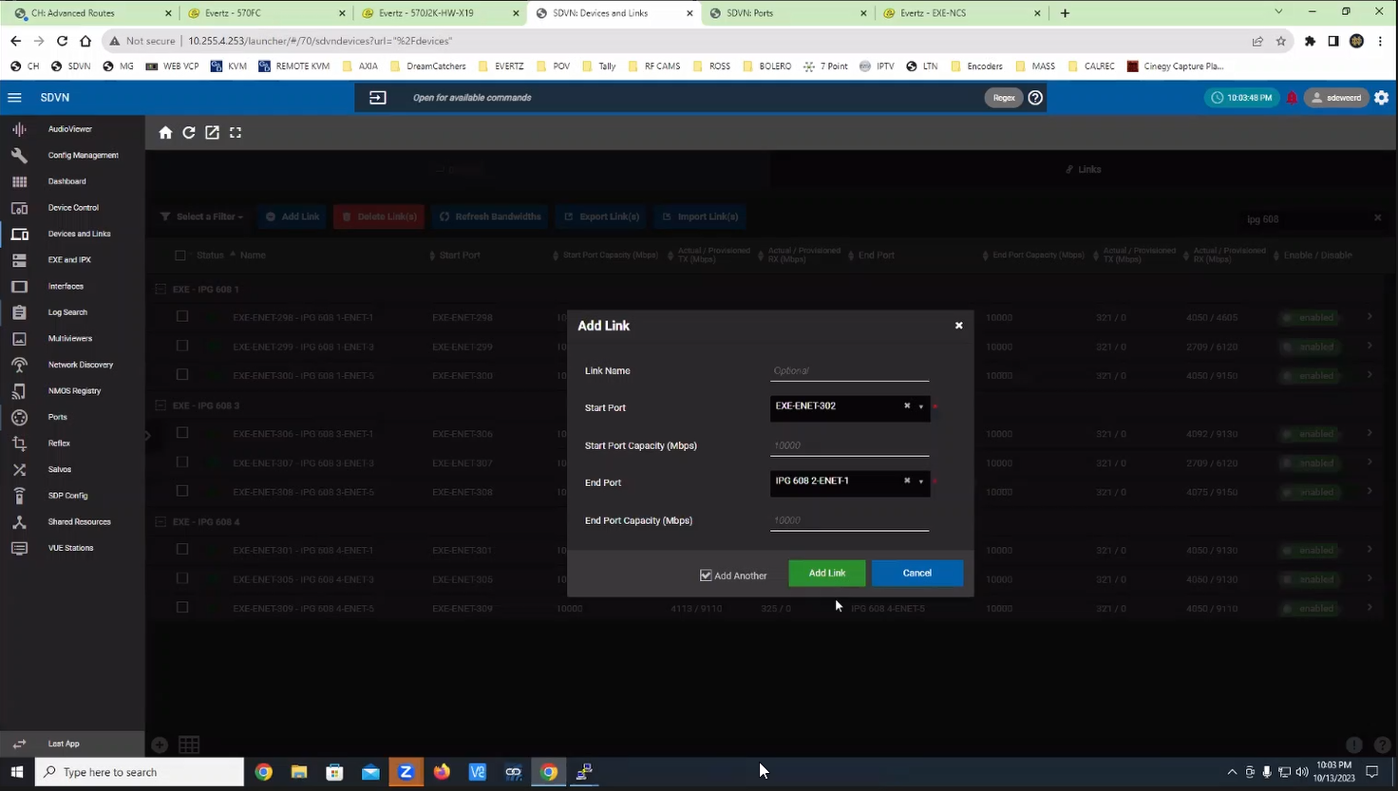
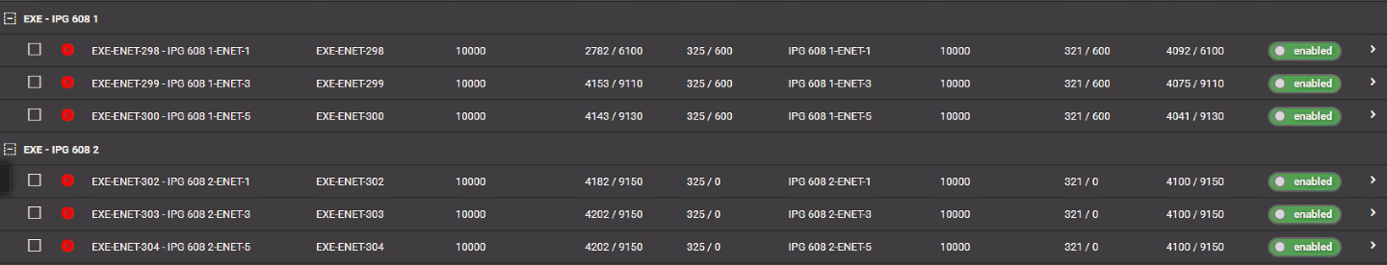

Setup Static Routes:
Magnum > Setup Static Routes > Setup Static Routes
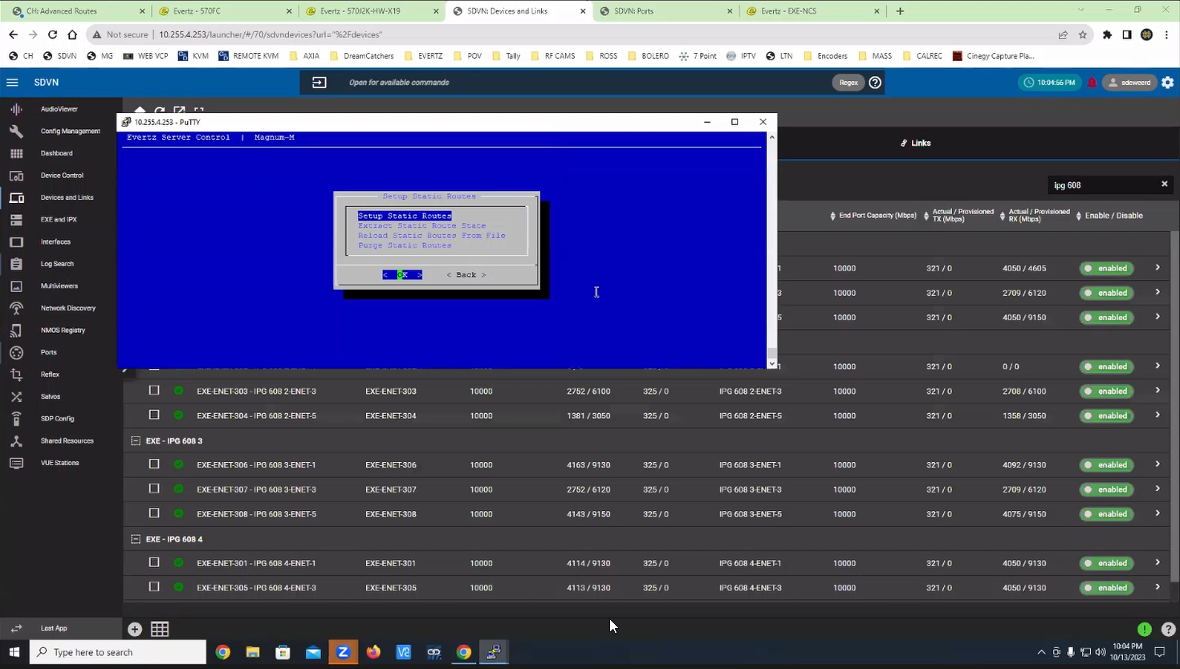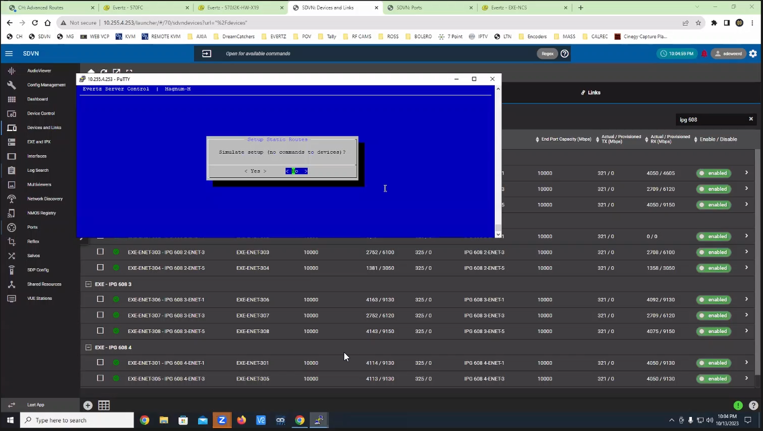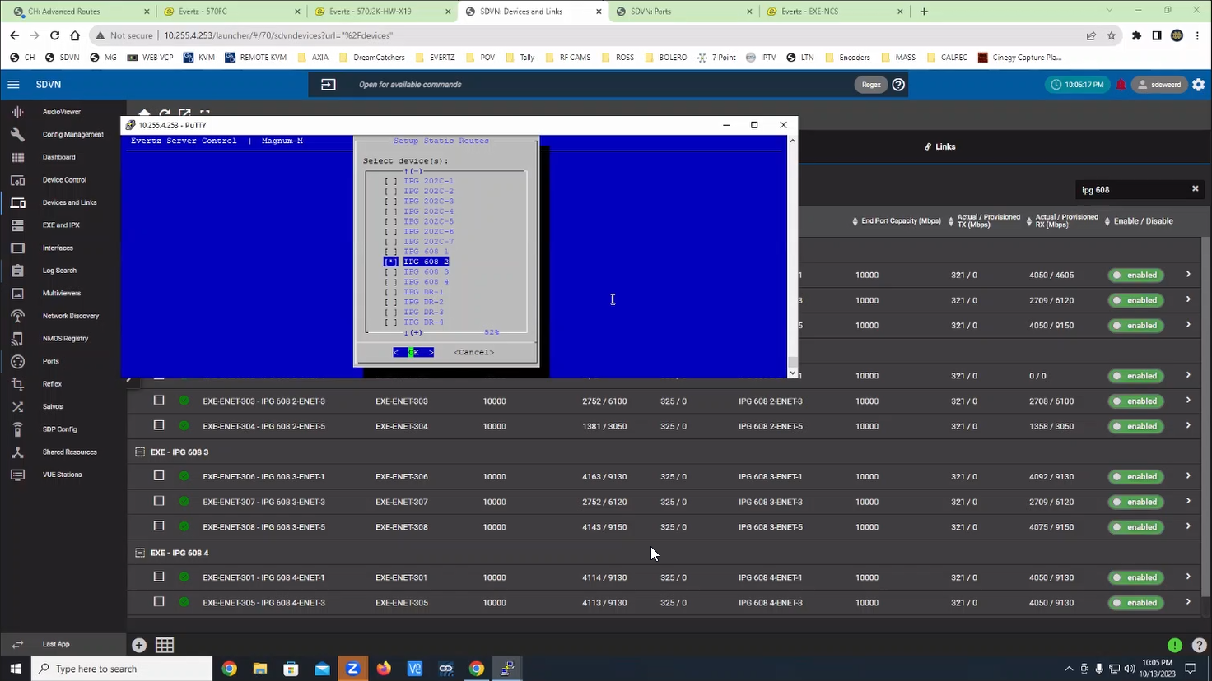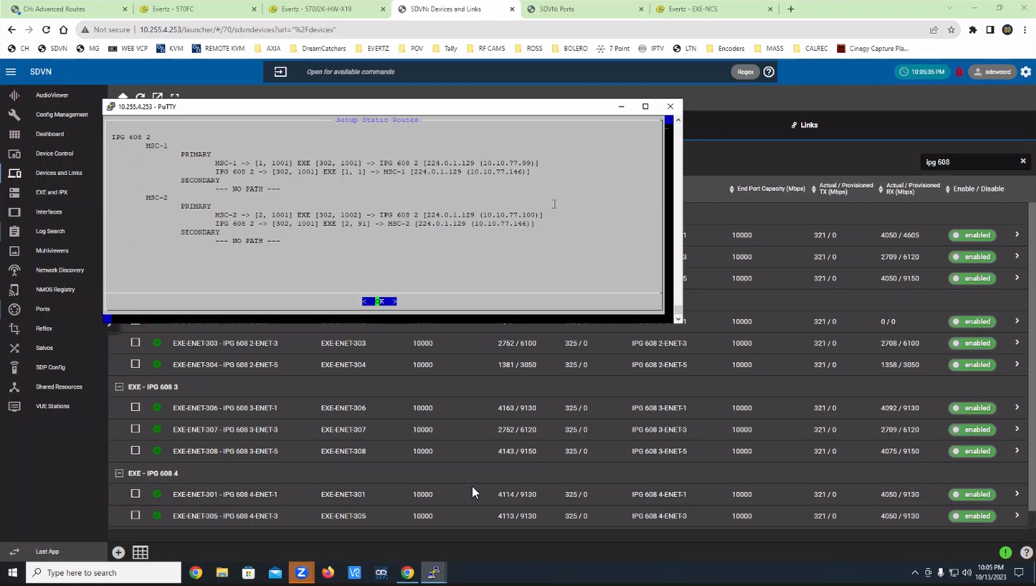

Device should now be connected to Magnum and in a Ready state
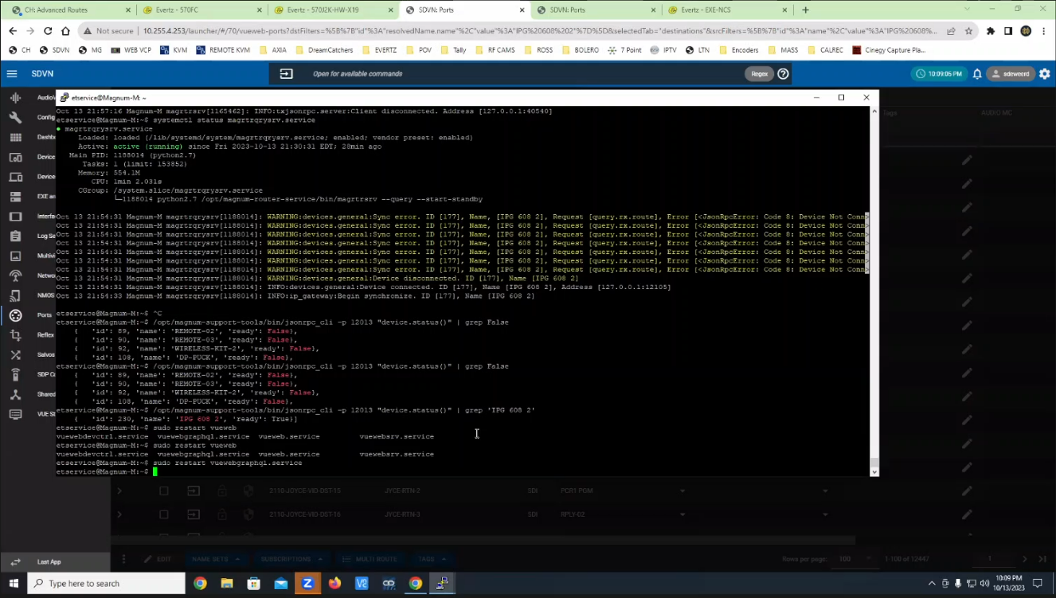

Device will still not take routes in Magnum CH > Advanced Routes > Virtual

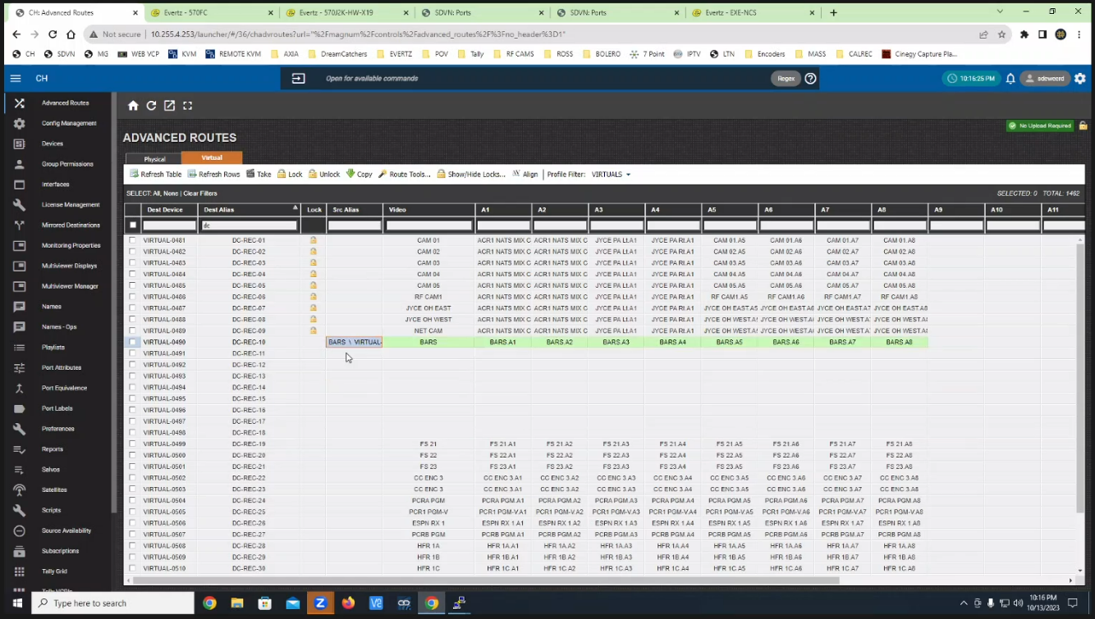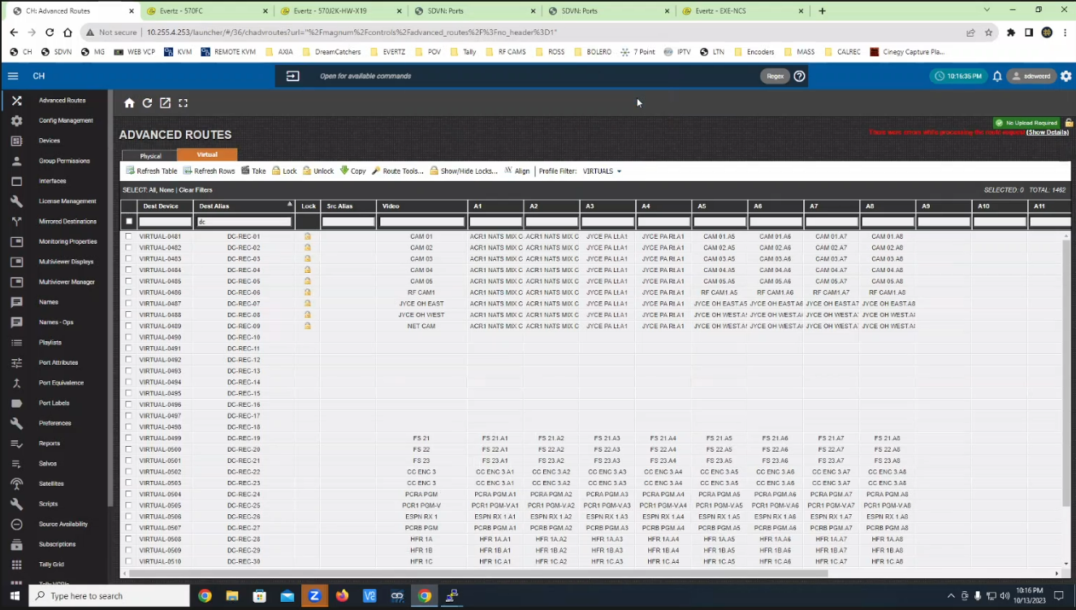

Readding the IPG caused the CH > Virtual Ports > Destination names to be reverted to the default names

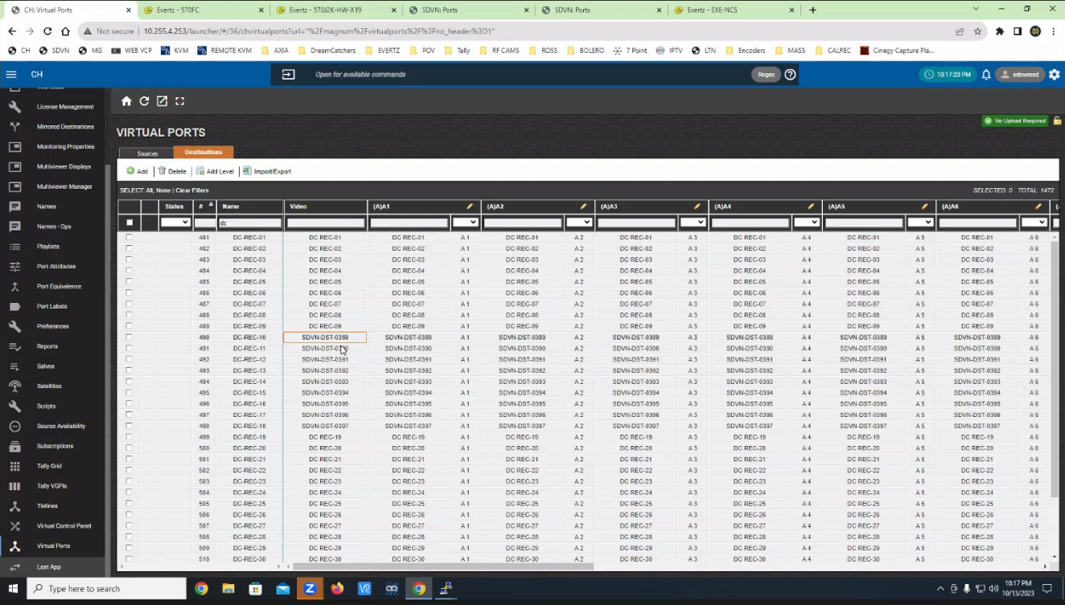

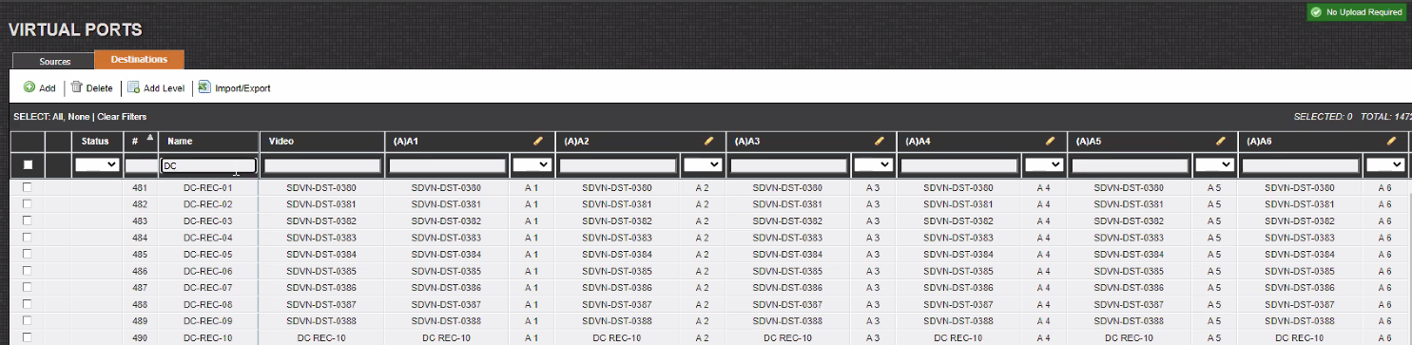

Under CH > Names > Destination, add the names and commit the changes
NOTE: this step is unnecessary, as it is done after the next step!

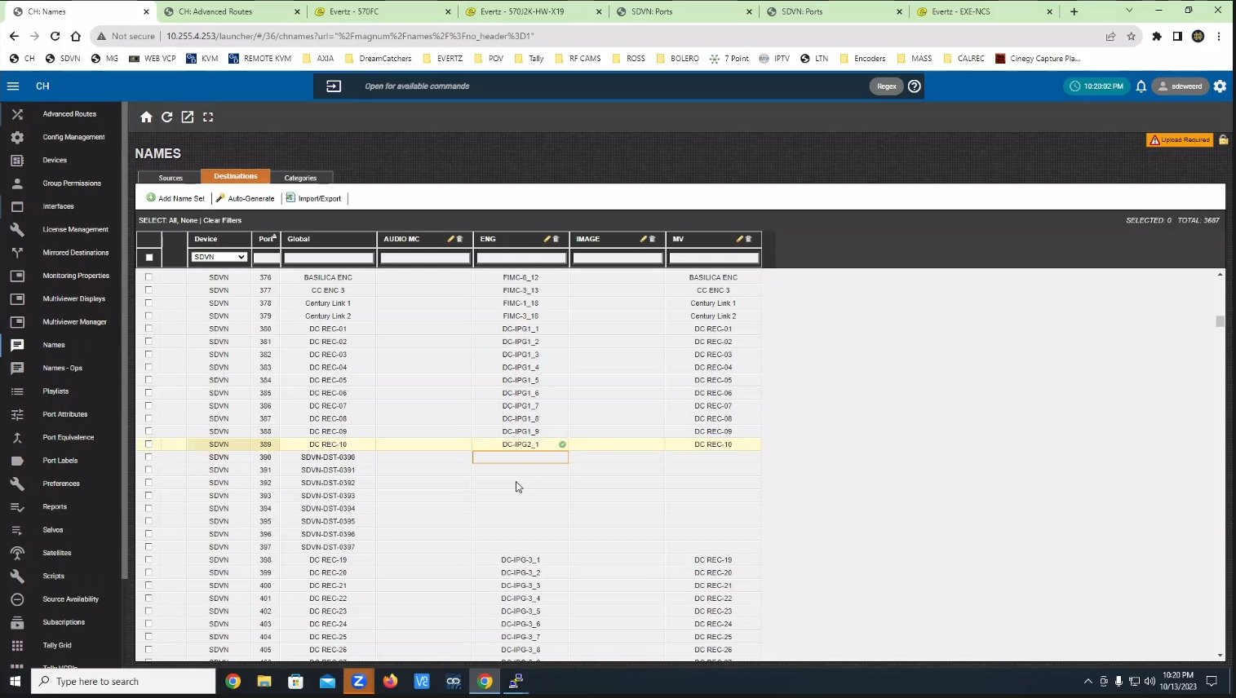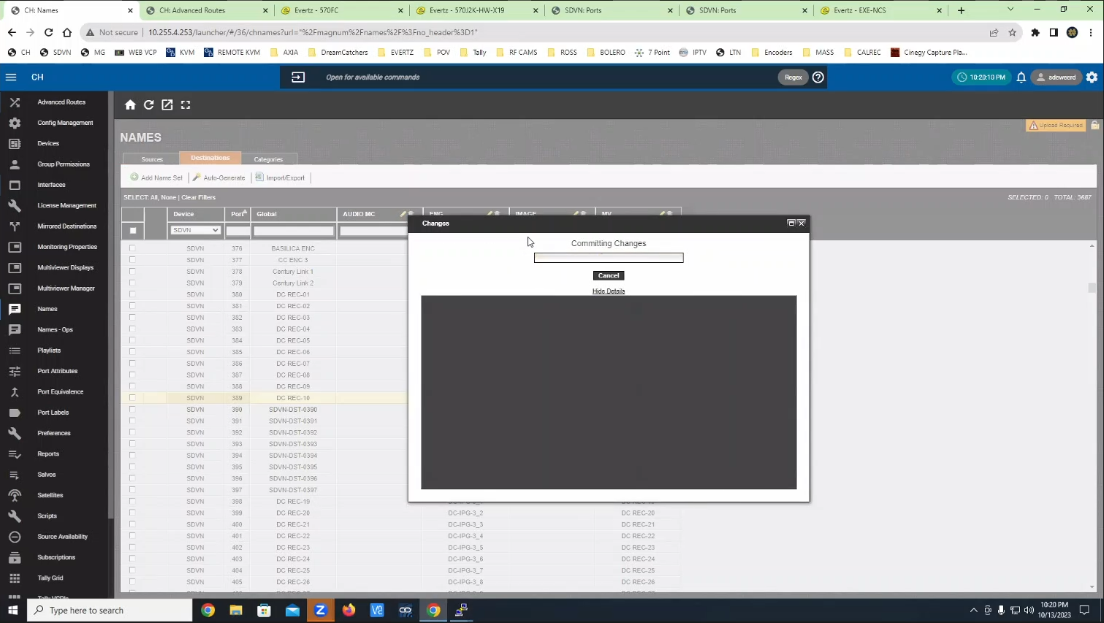

*WARNING*: Add the device destinations under SDVN > Interfaces > Destinations, under the right table
*WARNING*: Use the port number from the names tab (380-415)
*WARNING*: Do NOT forget to enter a number in the input field in the middle of the screen for the “Insert at Index” value. Then select the rows from the left table (columns can be filtered), and then press the add button in the middle of the screen.

Then verify that the device was added to the correct Order value.

Also, if extra blanks are accidentally added to the right table, they can removed by changing the drop-down in the middle of the screen and selecting “Don’t Leave Blanks” and then clicking the order column on the right, then selecting those blank rows and clicking the remove button.
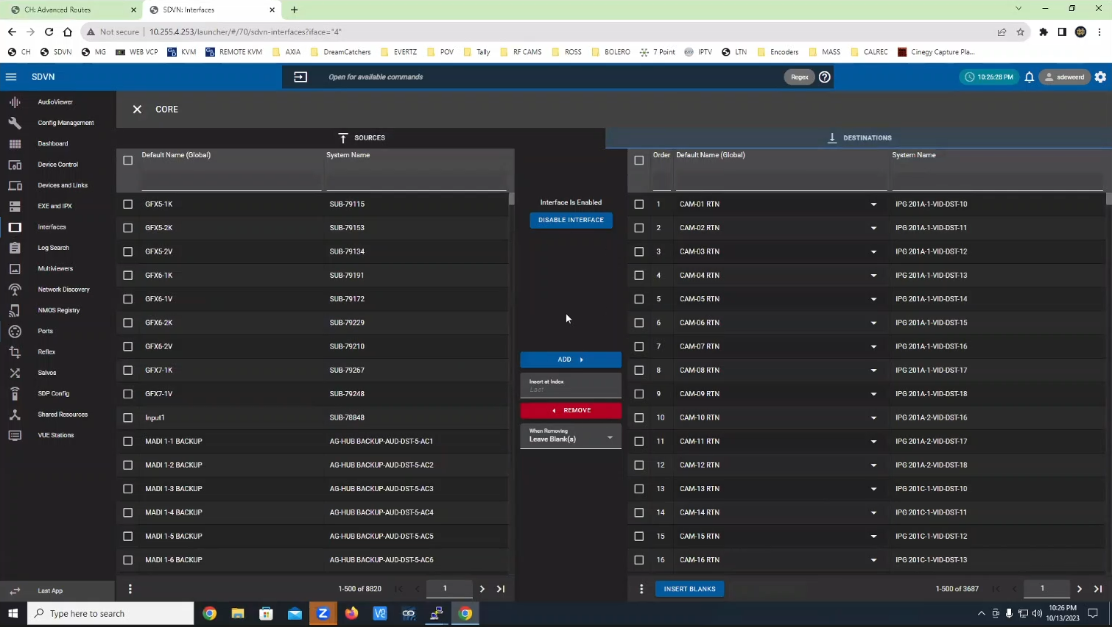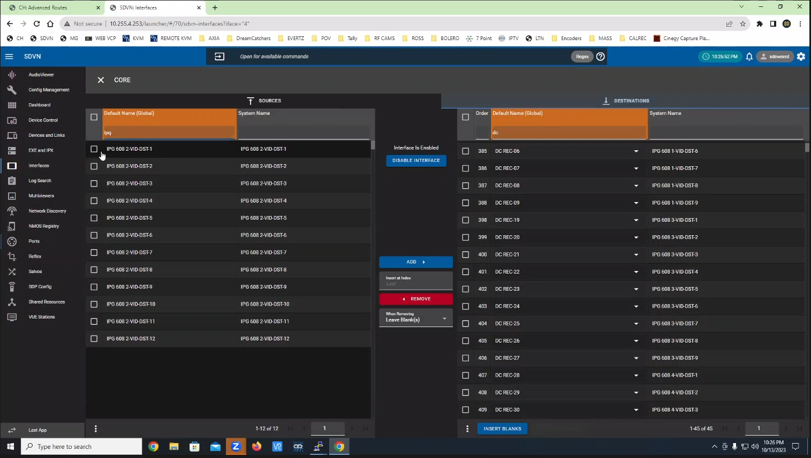
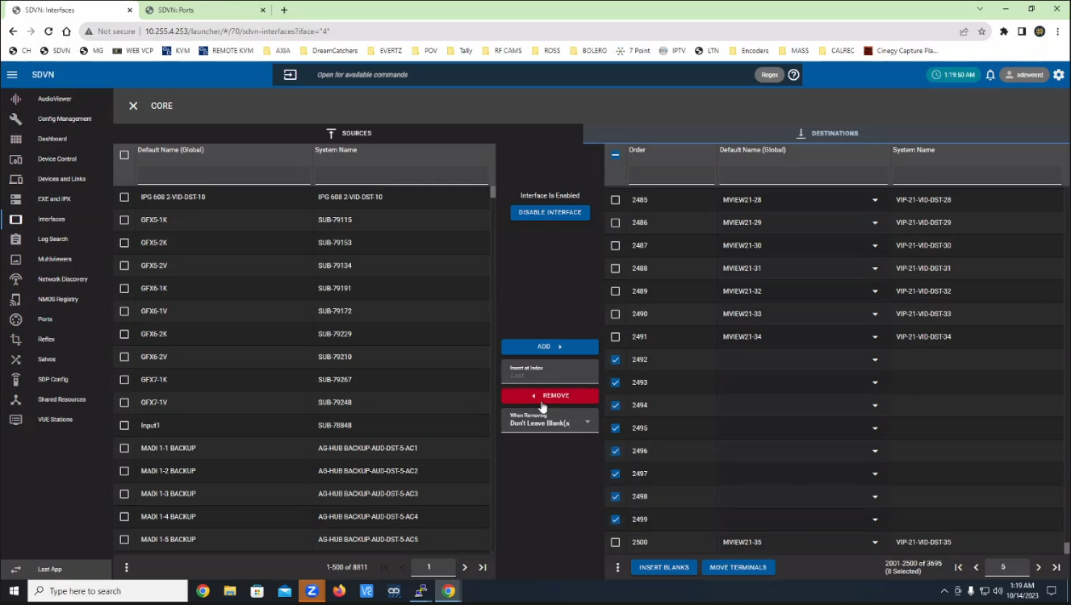

In CH > Names > Destinations add the names of the device and commit changes
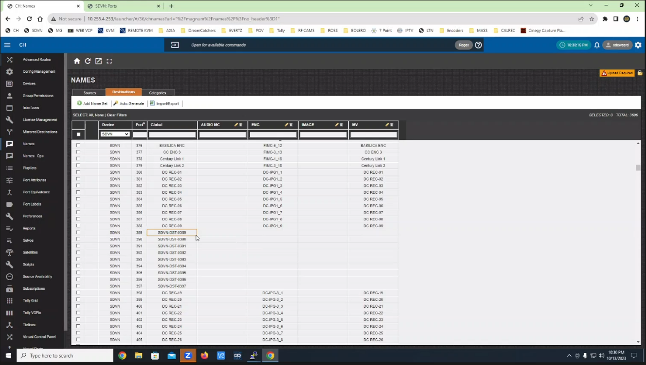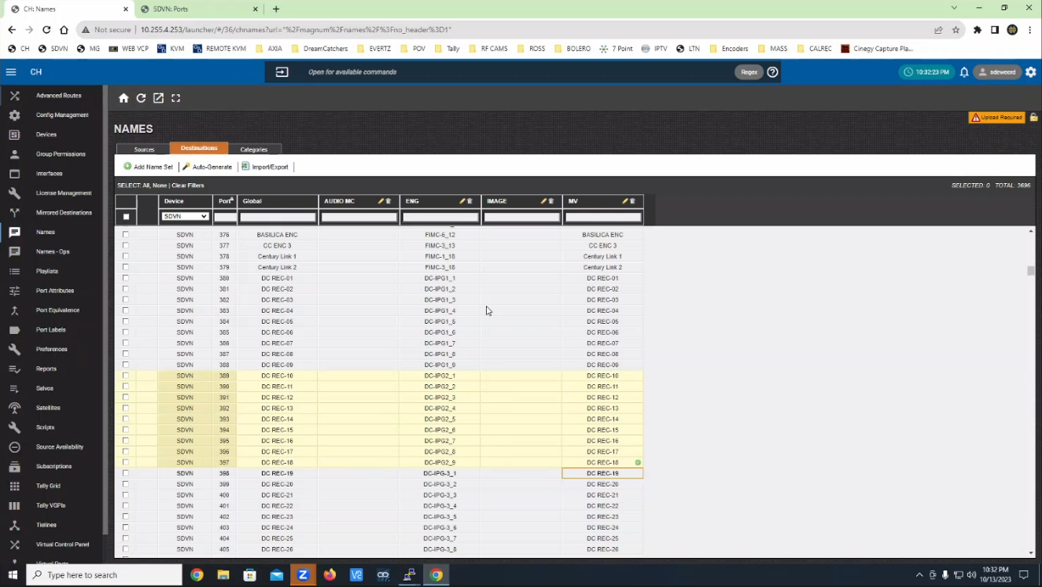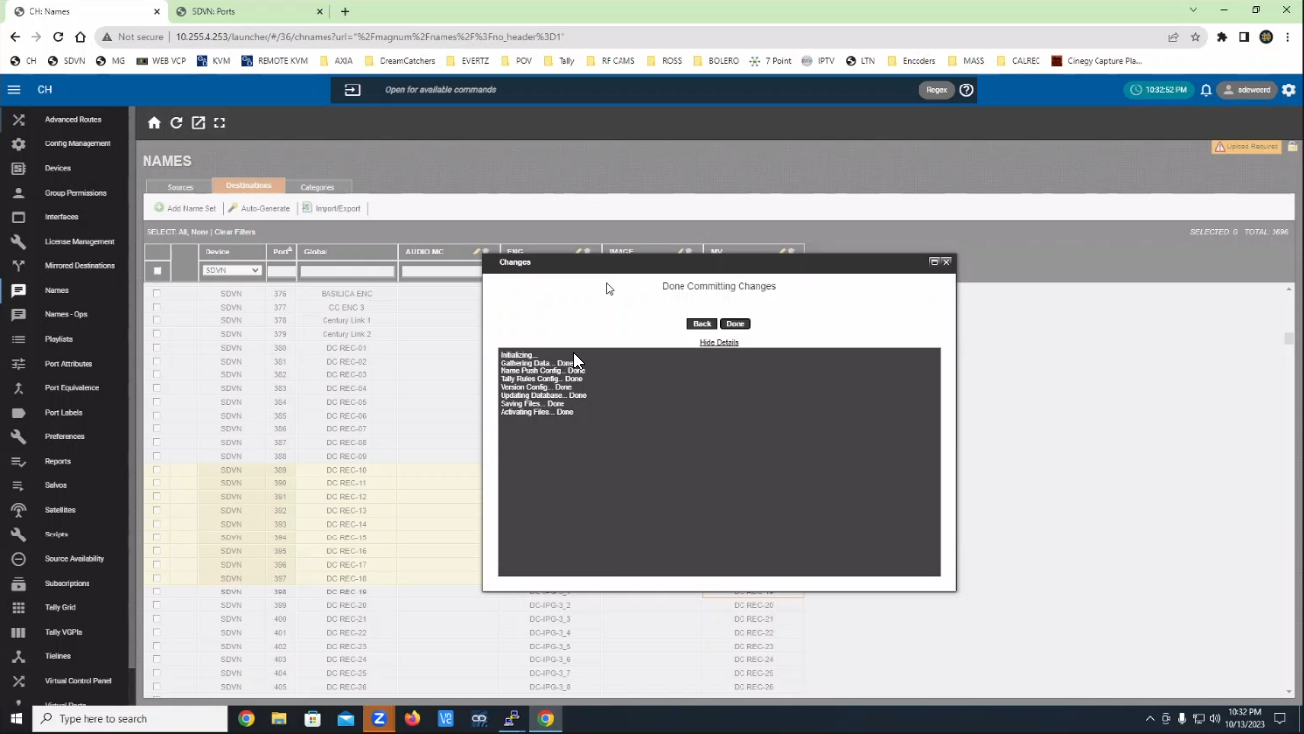

*NOTE*: In SDVN > Ports > Destinations, add the names to the Global and ENG columns
Do not add more names than those that exist (e.g. DC REC-19 should not have been added).
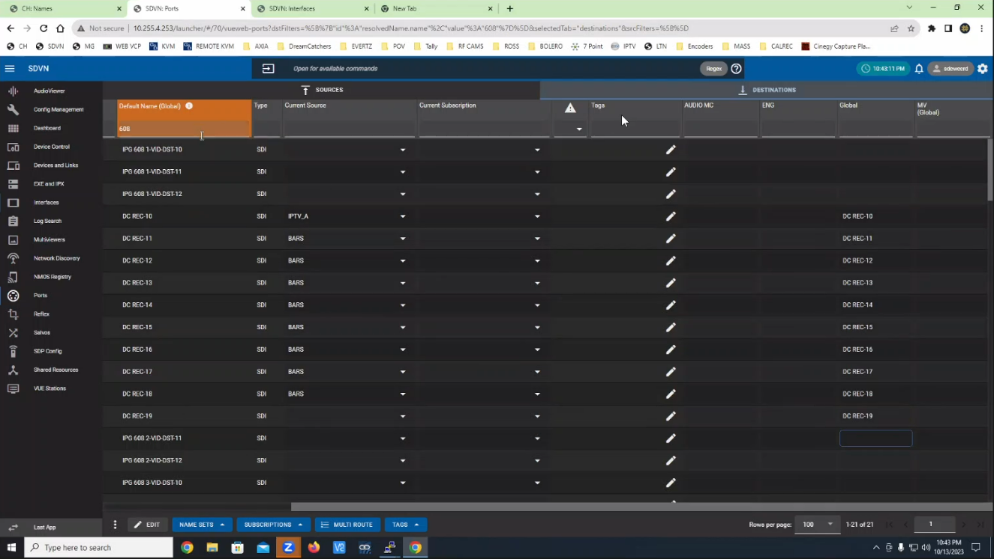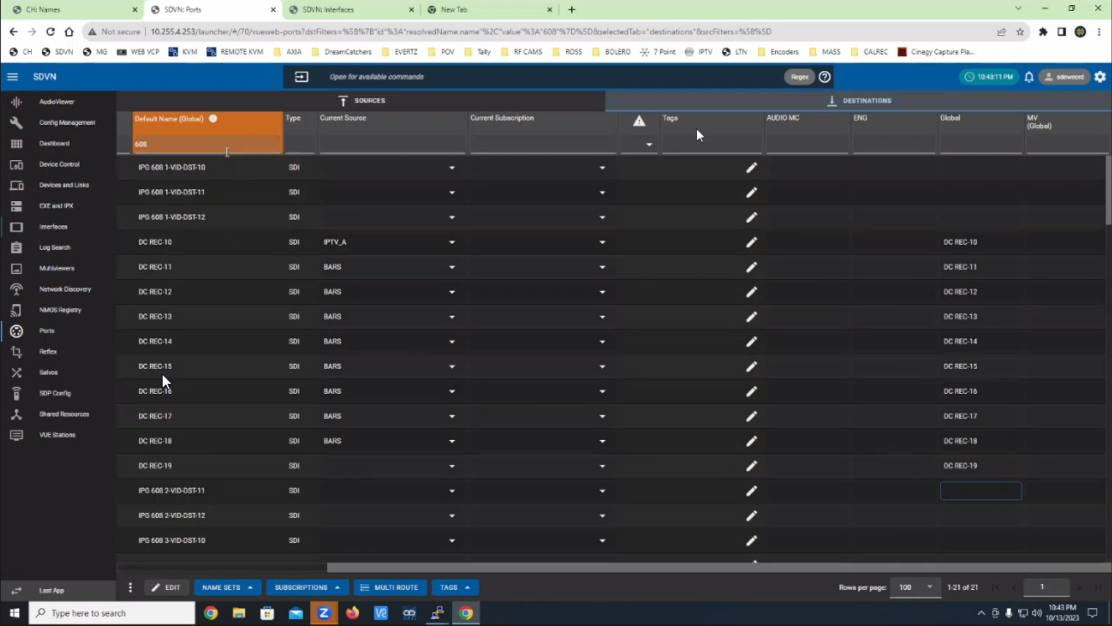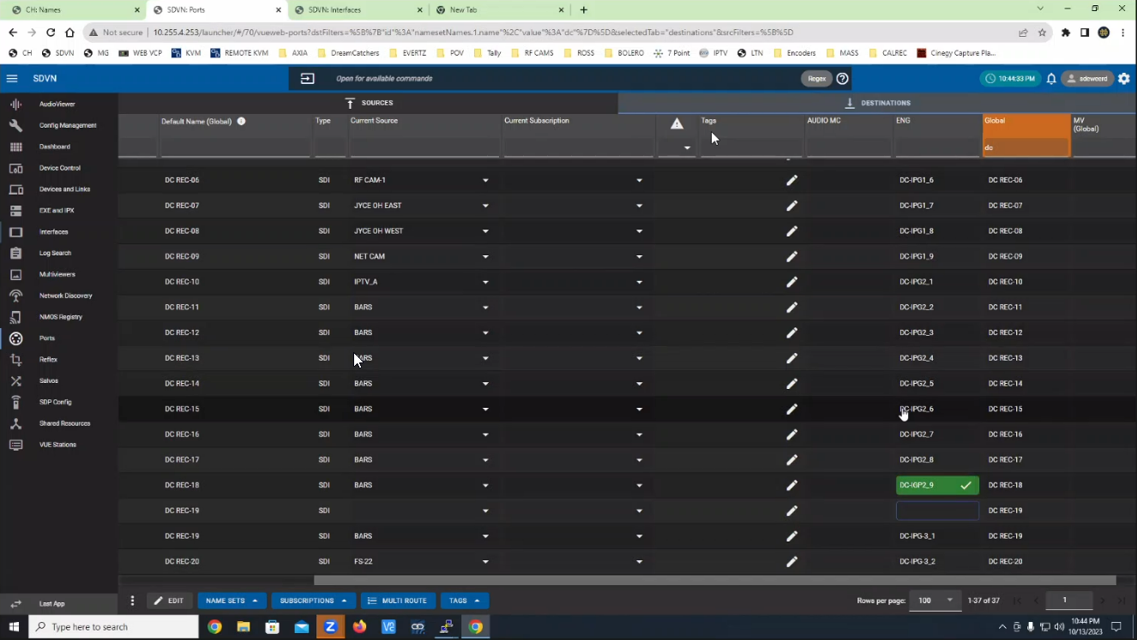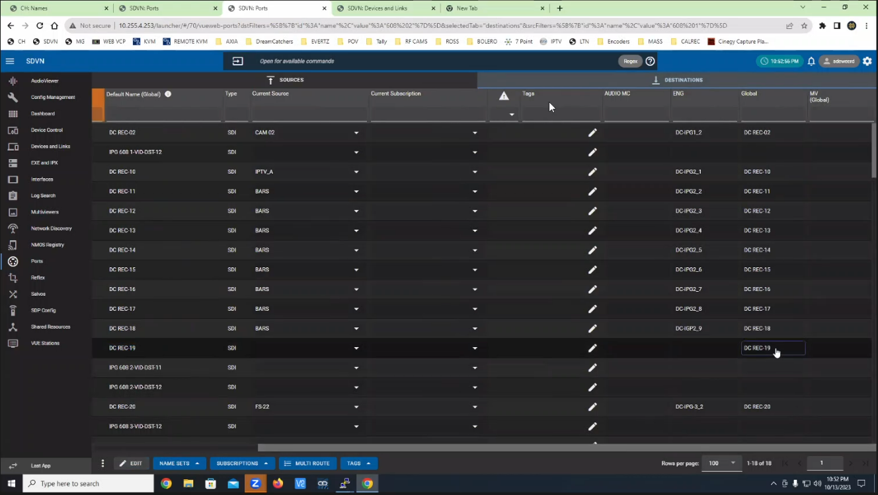

In CH > Source Availability, allow all sources to route to the new destinations and commit (if not needed, save will be greyed out)

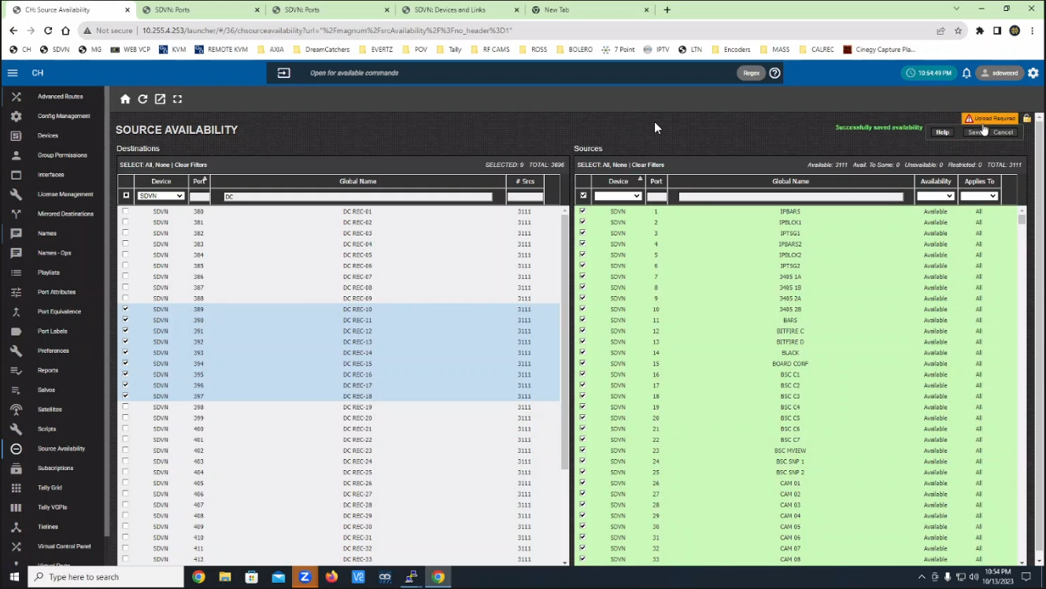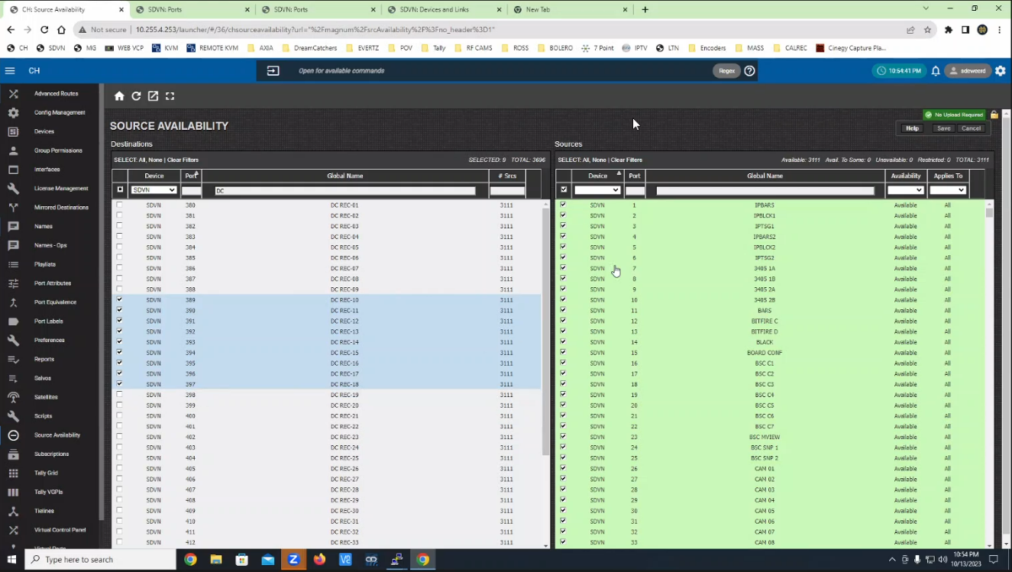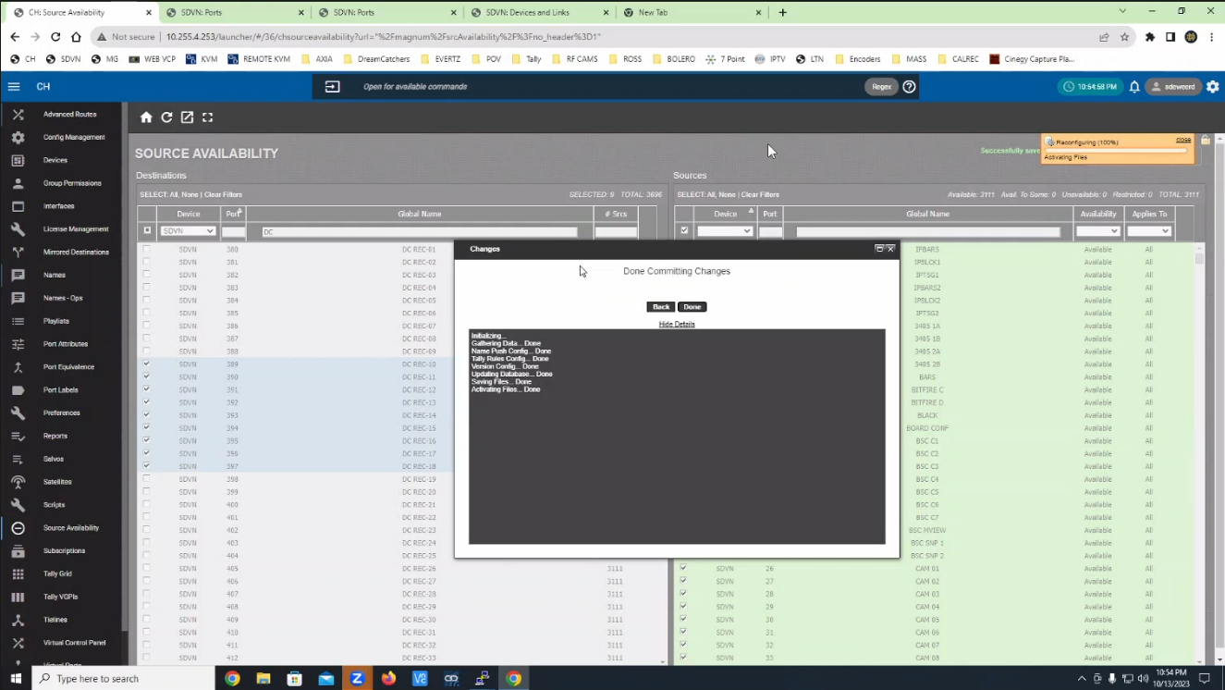

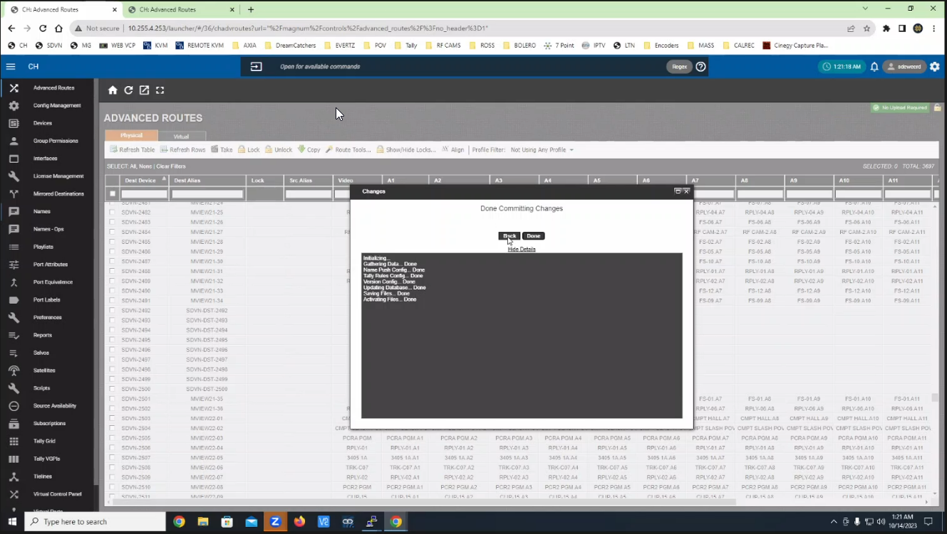

Device should now be routable in both SDVN and CH
The device should now be routable in both SDVN and CH.

(Optional) Monitoring the IPG Sync Status During a Broadcast:
Here is a short script that you can run directly on your Magnum server that will monitor the status of all of your devices every 5 seconds for when you have any production to make sure that the status of all devices are in the ready state.
Connect to Magnum through Putty and login to Linux using username etservice and password magnumhdtv, then write the following command all on one line:
beep() { read a || exit; printf "$(date +'%r') $a\007\n"; beep; }; while :; do cat <(/opt/magnum-support-tools/bin/jsonrpc_cli -p 12013 'device.status()') | gawk '!/REMOTE-02|REMOTE-03|WIRELESS-KIT-2|DP-PUCK/ && /False/' | beep; sleep 5s; done

You can test this command by opening a Putty session and typing the following commands:
/opt/magnum-support-tools/bin/jsonrpc_cli -p 12013 'device.status()' > test.log
then:
beep() { read a || exit; printf "$(date +'%r') $a\007\n"; beep; }; while :; do cat test.log | gawk '!/REMOTE-02|REMOTE-03|WIRELESS-KIT-2|DP-PUCK/ && /False/' | beep; sleep 5s; done
Then open another Putty session using the same login above, and run nano test.log to edit the file (use arrow keys and the instructions on bottom to save and quit the file when done), and now the other session should have the device that has been switched to False show up every 5 seconds, along with an audible beep sound.

Here’s a description of what the first command given above does:
Define the beep function, which will make the terminal beep, and adds the date to the output, and then creates an infinite loop where every 5 seconds the status of all devices are checked, and any device which returns false and are not the following devices (REMOTE-02, REMOTE-03, WIRELESSS-KIT-2, DP-PUCK) will be sent to the beep command, then it will wait 5 seconds and repeat from the beginning of the loop.

